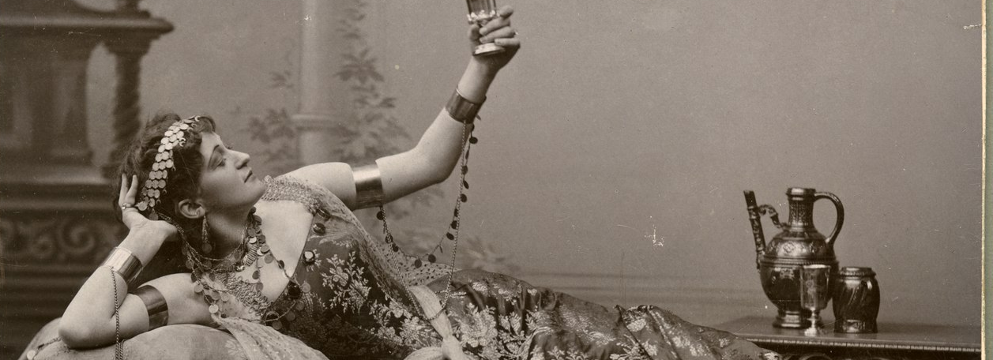
Call for Papers:
Women’s Spaces, Pleasure, and Desire in the Belle Époque

***EXTENDED DEADLINE: Midnight on Friday, 19th April***

3-4 June, 2019. St Hilda’s College, Oxford.
Convenors: Sasha Rasmussen (St Hilda’s), Rhiannon Easterbrook (Women in the Humanities Post-doctoral Writing Fellow) and Mara Gold (St Hilda’s).

Even as women asserted their presence in universities and the new department stores that proliferated to cater to their desires, at the turn of the century many still imagined feminine space in traditional archetypes: the tranquillity of the home, or the exoticism of the harem. To speak of women’s spaces during the Belle Epoque, then, calls forth a host of simultaneous possibilities, ranging from the archaic to the shockingly modern, from the sensual to the cerebral. In public or in private, this conference seeks to examine the relationships between women, space, pleasure, and desire. We invite submissions that explore how different forms of women’s space competed and co-existed around the world at the end of the nineteenth and beginning of the twentieth centuries, and how these represented, structured or suppressed women’s experiences of desire and pleasure.

Topics could include, but are naturally not limited to:

- Homosociality and homosexuality
- Trans and queer experiences of space
- Women’s political organising
- Shopping and consumer culture
- Traditional and alternative domesticities
- Performance, literature, and the visual arts
- Institutions, including educational establishments
- Desire, pleasure, and the senses
- Women and colonialism

We welcome submissions for papers of 20 minutes from researchers in any relevant discipline. If you would like to propose an alternative form presentation – such as a performance, artwork or installation, or PechaKucha – we are also be interested to hear from you. Please submit an abstract of no more than 250 words to Sasha Rasmussen (sasha.rasmussen@st-hildas.ox.ac.uk).

Attendance and Fees
We hope to announce decisions on all submissions by Monday 22 April. Registration fees will be kept to a minimum (under £10), and we hope to be able to offer some small bursaries towards travel and childcare.
Generously supported by:

