



Are the Dogs Running Today?
Bathsheba Demuth (Brown University)
Flagship lecture

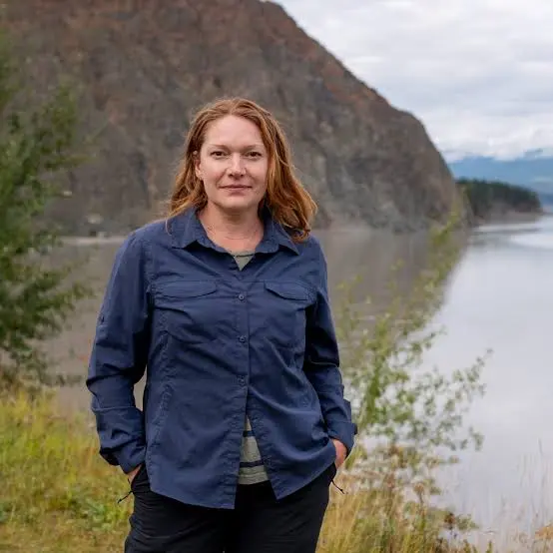

Professor Bathsheba Demuth is Dean’s Associate Professor of History and Environment and Society, Director of Native American and Indigenous Studies Initiative at Brown University. Author of the award-winning Floating Coast: An Environmental History of the Bering Strait (2019), she is an environmental historian, specializing in the lands and seas of the Russian and North American Arctic. From the archive to the dog sled, she is interested in the how the histories of people, ideas, places, and non-human species intersect.

This talk blends history, ecology, and personal experience to explore the long relationship between people, sled dogs, and salmon along the Yukon River watershed in Alaska and western Canada. As dogsledding and fishing have long been deeply intertwined parts of living close to the land, this talk looks at the stakes of a changing environment and climate—changes that could alter where we live and the animals we live with and the rivers that are their home.

Thursday 6th of November
12:00-1:30pm
Schwarzman Centre

*Please register on our website

