Thursday, 21 September
9.00–9.15 | Registration
9.15–9.30 | Welcome
9.30–11.00 | Spaces and practices: Representation and entertainment  Chair: Prof. Steve Gunn (University of Oxford)  Kristoffer Schmidt (Museum of Northern Zealand): The Danish par force hunt as an informal space of diplomacy (1670-1760)  José Antonio Diaz-Gomez (University of Granada): Spaces for Diplomacy and Fascination: Cabinets of Curiosities in the Hispanic Enlightenment  Aidan Jones (King’s College London): Entertaining tsardom: Nicholas I’s visit to conservative England
COFFEE
11.30–13.00 | Spaces and practices: Education, letterwriting, and dancing  Chair: Dr. Tracey Sowerby (University of Oxford)  Maximillian Diemer & Antonio Pattori (New College, University of Oxford): The duchy of Parma between Vienna and Paris: informal aspects of enlightened diplomacy (1748-1789)  Edwina Hagen & Lisa Bakhuizen van den Brinck (VU University Amsterdam): The diplomacy of friendship. Emotions in letters as a diplomatic practice. A reconstruction based on the incoming mail of Geertruida Francisca van der Goes-de Eerens, informal diplomat at the Danish court, 1785-1793  Hilary Burlock (University of Newcastle): The Dance of Diplomacy: Sociabilities and identities in British imperial outposts
LUNCH
14.00–15.00 | Language  Chair: Prof. Nicole Pohl (Oxford Brookes University)  Sophie Holm (German Historical Institute Moscow (Helsinki) / Max Weber Foundation): Creating informal spaces through language – Linguistic practices in Swedish eighteenth-century diplomatic correspondences  Vladislav Rjéoutski (German Historical Institute, Paris), Vladimir Somov (independent scholar): Family correspondence as a diplomatic space in eighteenth-century Russia: Jacob and Peter von Staehlin (1760s-1780s)
COFFEE
15.30–17.00 | The Napoleonic Wars and the Congress of Vienna  Chair: Dr. Michael Drolet (University of Oxford)  John Condren (University of Nottingham): Making Geneva Swiss: informality in the negotiations of Charles Pictet de Rochemont at the Congress of Vienna, 1814-1815  Lucas Rijntalder (VU University Amsterdam): Through the eyes of von Gentz: Emotions and emotional diplomacy during the Congress of Vienna, 1814-15  Rasmus Glenthøj (University of Southern Denmark): Diplomacy, nationalism and revolution: Bismarck and Scandinavia
17.15–18.15 | KEYNOTE: Prof. Glenda Sluga (EUI): Where does the history of diplomacy belong?
19.00– | DINNER: Al-Shami Lebanese restaurant,  Address: 25 Walton Crescent, OX1 2JG Oxford

Friday, 22 September
9.00–10.00 | Sea, trade and beyond  Chair: Dr. John Condren (University of Nottingham)  Erik de Lange (King’s College London): Beyond the Gunboat: The Ship as a Site of Diplomacy  Ben Pollitt (Courtauld Institute of Art): The Sympathetic Cannibal: A Satire (on Diplomacy)
COFFEE
10.30–11.30 | Slavery and abolition  Chair: Michael Depreter  Rana Aldemir (Central European University): Diplomatic Intrigue in Vienna: Unearthing the Role of the Ottoman Slave and an Austrian Countess  Kate Rivington (Monash University): Maria Weston Chapman, French Salons and the Sociability of Antislavery in the Mid- Nineteenth Century
11.30–12.30 | (In)formal diplomacy in the Maghreb  Chair: Kristine Dyrmann  Majid Embarech (Université Côte d’Azur): A cordial understanding? Commercial and financial relations between the kingdom of France and the deys of Algiers (1750-1792)  Florian Ambach (Universität Innsbruck): Translator, informant, spy? Franz Dombay and the (in)formal channels of Austrian diplomacy in Morocco (1783–1792)
LUNCH
COFFEE
13.30–14.30 | Final comment & Closing remarks  Prof. Elaine Chalus (University of Liverpool)  Kristine Dyrmann
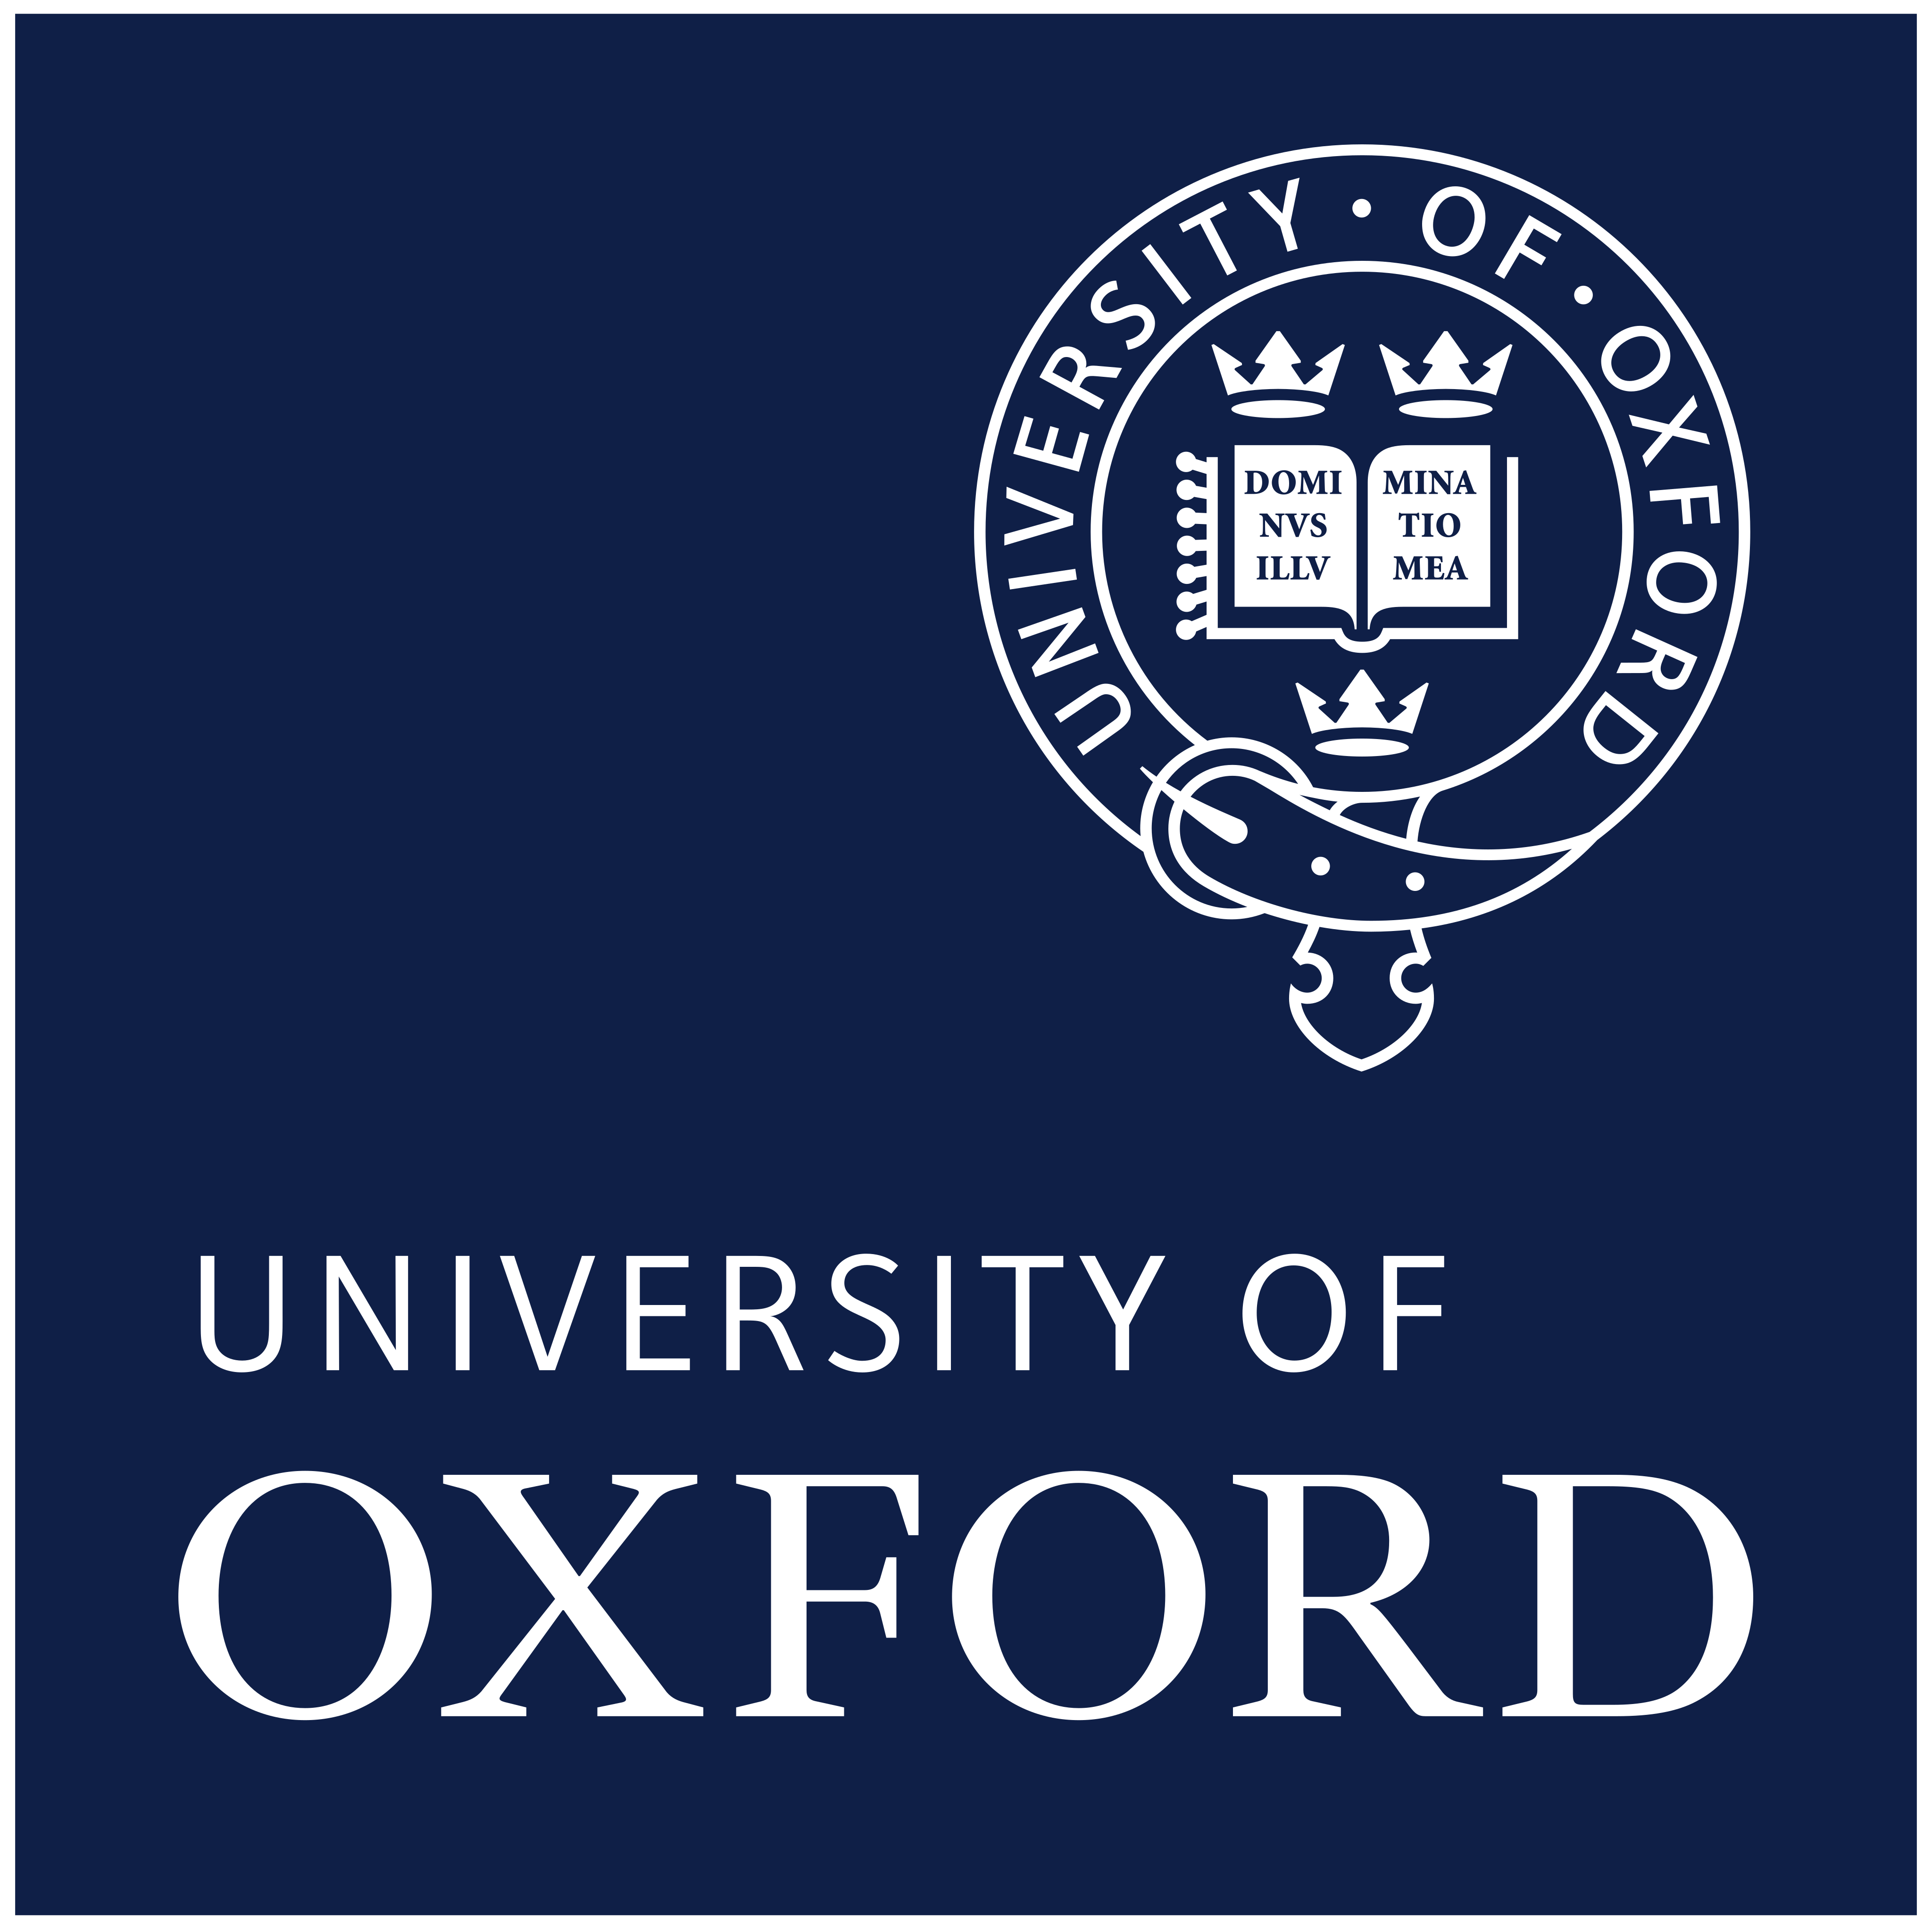
Informal Oxford walking tour

